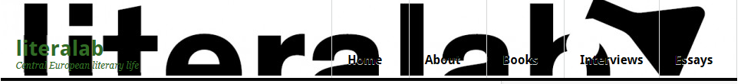

Interview with Spomenka Stimec
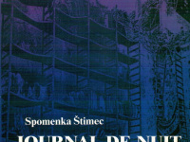
Spomenka Štimec, who writes in both her native Croatian as well as Esperanto, recently had her book Croatian War Nocturnal published in an English translation by Sebastian Schulman by Phoneme Media. I conducted an interview with her by way of e-mail and Sebastian Schulman’s translation from Esperanto, where she speaks about beginning to write in the language, the difference between writing in Esperanto and Croatian, what she’s working on now and more.
Literalab: How and when did you first think of writing in Esperanto?
I first began writing in Esperanto while in the United States in 1978. Around me buzzed and bustled the sound of English, a language I did not speak, and a people whose concerns were so different from my own. In the evenings, I sat at my desk with a pen in hand to jot down a few ideas from my feelings of isolation and poverty. And the words poured out in Esperanto so beautifully, so lightly.
Writing in Esperanto gave me a sense of liberation, of being unchained, of a kind of homecoming. The tale I began working on then became my short story “The Land Unable to Pay Its Debts” (La nepagipova lando). The story received an award as part of the annual Belarta Konkurso (“Belles-lettres Competition) at the 1978 Universal Congress of Esperanto in Varna, Bulgaria. The praise I heard there, as well as the diploma signed by Baldur Ragnarsson—the marvelous Esperanto-language poet from Iceland—and the small honorarium I received all added to the pleasure I got from the writing itself. From that, I understood how the Esperanto community would react to my writing. The next time I sat at my desk, I stared at the tip of my pen trying to decide in what language to write and Esperanto just began to flow.
Literalab: What did it mean to you to write specifically about the war in Esperanto? How much different would the book have been if you had written it in Croatian?
I like the idea that there exists an Esperanto community, a group of people who read literature in Esperanto. I have had the pleasure many times of meeting my readers spread throughout the Esperanto world. When the war began in my country, in Croatia, in 1991, I had the feeling that wars were happening at the same time all over the world, but now here I was, an Esperanto-language writer who could serve as this war’s witness. Not every war-torn region has among its Esperantists someone who will bear direct witness, someone for whom their own wartime experiences suggest themselves as a literary subject so readily.
Since the Esperanto-reading public is so spread out and quite far away, I must sometimes clarify some of the culturally specific references in my work when I write in Esperanto. So, yes, this book would have been quite different had I written it in Croatian. But the Croatian reading public has had many authors who have produced an abundant literature on the theme of war. Indeed, the residents of Croatia saw war three times in the 20th century. Yet in 1991, when I wrote Croatian War Nocturnal, there were few Esperanto writers anywhere who wrote about the personal, lived experience of military conflict. Afterwards, I wrote about the war in Croatian as well. In 2014, for example, a Croatian-language collection of war stories A Tale From the Patriotic War was released, which featured my story “A Student of Slavic Studies”. The Writers’ Union had held a contest looking for screenplays and from that competition came this book. An Esperanto version of the same story recently appeared in a 2017 issue of the New York-based literary journal Beletra Almanako. It’s a continuation from Croatian War Nocturnal of the story about the town of Vukovar.
Literalab: How different is the process for you writing in Esperanto and Croatian? Is it easier in Croatian, or is there something perhaps more liberating or otherwise different writing in Esperanto?
It’s difficult for me to describe processes. Writing in Croatian and writing in Esperanto are both liberating, but in different ways. The way of thinking is different, as well as the metaphors, the explanations, and… the audience.
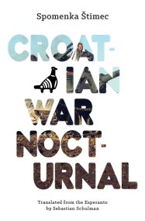
Literalab: Has the novel been translated into Croatian, and if so, how was it received?
Croatian War Nocturnal has not been translated into Croatian. The book first appeared in Esperanto in Vienna, Austria. Interest grew shortly thereafter and it has been published in Japanese, German, Chinese, Icelandic, and French editions. At first, this was with publishers that who already had a special interest in Esperanto. The work of the translators—who felt the need to share this book with others in their home countries and were compelled to find publishers—is truly admirable.
Literalab: Do you have plans for your next Esperanto novel and/or Croatian novel?
My most recent book was published in Croatian in 2016. It’s called Dom u Srednjoj Europi, which means “A Home in Central Europe.” It consists primarily of translations and adaptations from my Esperanto-language works, including a few fragments from Croatian War Nocturnal. The book also contains prose written solely in Croatian.
Right now, I am busy preparing the footnotes for the Japanese translation of my Esperanto-language book Hodler en Mostar (“Holder in Mostar,” Edistudio 2006).
Literalab: Since the book was first published there have been many books and films about the war that have given people who didn’t experience it various impressions and experiences of what took place. After all this time what do you think stands out from Croatian War Nocturnal as an overall impression that a reader will take away about the war?
I would it like it if my book, after all this time, could serve as a close illustration of what the Russian poet Marina Tsvetaeva meant when she said (and I here I paraphrase), “with war it is like this: machine gun versus machine gun, but not Aleksandr Blok versus Rainer Maria Rilke.”

